## Mini-Project: The Data Science Life Cycle

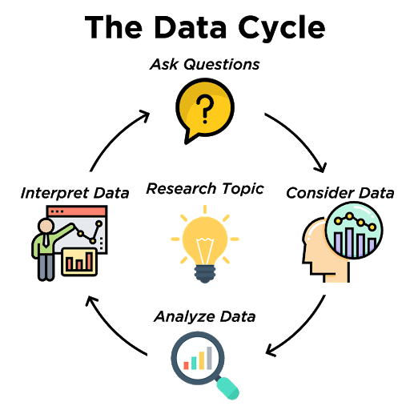

**Mini-Project:**

In this lesson, you will go through the first two steps of the data cycle.

* *Ask Questions*: Formulate a statistical question that can be answered with data.
* *Consider Data*: Collect or find data that will aid in answering your question.

The best part of this mini-project is that your statistical question can revolve around anything! Think of something that you are interested in and brainstorm a few questions that you would be curious to learn more about.

*Fun Examples:*

* Who is the best football player on the NY Giants?
* Which child Disney star became the most successful later in life?
* Who would win in a battle between Marvel and DC superheroes?

*Social Equity Examples:*

* How well do bridge programs help first-gen college students succeed in their first year?
* Does playing sports help girls in their sense of self-awareness and self-imagery?
* Does the distance to a grocery store have an impact on health and eating habits?

Brainstorm and list at least three statistical questions

that you would like to explore further.

1.

2.

3.